Computer Organization & Assembly Language
Lab 08
Topics:
- While Loop
- Conditional Loops
- Interrupts
While Loop
While loop tests a condition before performing a block of statements. As long as the condition remains true, statements are repeated.
Example:

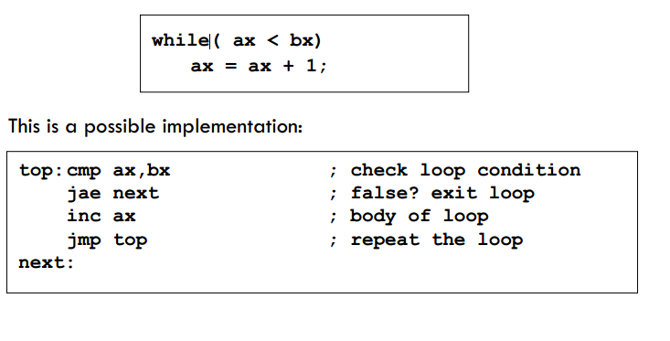
- LOOPZ (Loop if Zero):
The LOOPZ instruction is an x86 assembly language command that facilitates conditional looping in a program. It repeatedly executes a specific block of code as long as the zero flag (ZF) in the CPU's flags register is set. This instruction is particularly useful for scenarios where you want to iterate through a loop until a specific condition is met, and that condition involves checking if a certain result or variable is zero.
- LOOPE (Loop if Equal):
LOOPE is another x86 assembly instruction that enables conditional looping. It continues to execute a designated code block as long as both the zero flag (ZF) is set and the counter register (typically CX or ECX) is not zero. LOOPE is often employed in scenarios where you need to repeatedly perform an action until a specific equality condition is satisfied, such as searching for a particular element in an array or list.
- LOOPNZ (Loop if Not Zero):
The LOOPNZ instruction, similar to LOOPZ, is used for implementing conditional loops in assembly language programs. It repeatedly executes a specified block of code as long as the zero flag (ZF) is clear and the counter register (CX or ECX) is not zero. LOOPNZ is commonly employed when you want to iterate through a loop until a condition that involves checking if a value is not zero is met.
- LOOPNE (Loop if Not Equal):
LOOPNE is an x86 assembly instruction that creates a conditional loop. It continues to execute a designated code block as long as both the zero flag (ZF) is clear and the counter register (typically CX or ECX) is not zero. LOOPNE is often used when you need to repeatedly perform an action until a specific inequality condition is satisfied, such as searching for a specific element in a data structure while ensuring it is not equal to the desired value.
Interrupt
- An interrupt is an event that causes the processor to suspend its present task and transfer control to a new program called the interrupt service routine (ISR).
- Three sources of interrupts
- Software interrupts
- Hardware interrupts
- Processor interrupts

Common Software Interrupts:
The Common Interrupts are
GetStdHandle PROTO
WriteConsoleA PROTO, a1:DWORD, a2: PTR BYTE, a3: Dword, a4: ptr dword, a5: dword
ReadConsoleA PROTO, a1:DWORD, a2: PTR BYTE, a3: Dword, a4: ptr dword, a5: dword
invoke ReadConsoleA, eax, offset buffer, lengthof buffer, offset x, 0

Tasks:
- Write an assembly program to check whether a number is prime or not. If prime, move it in DL else move it in DH.
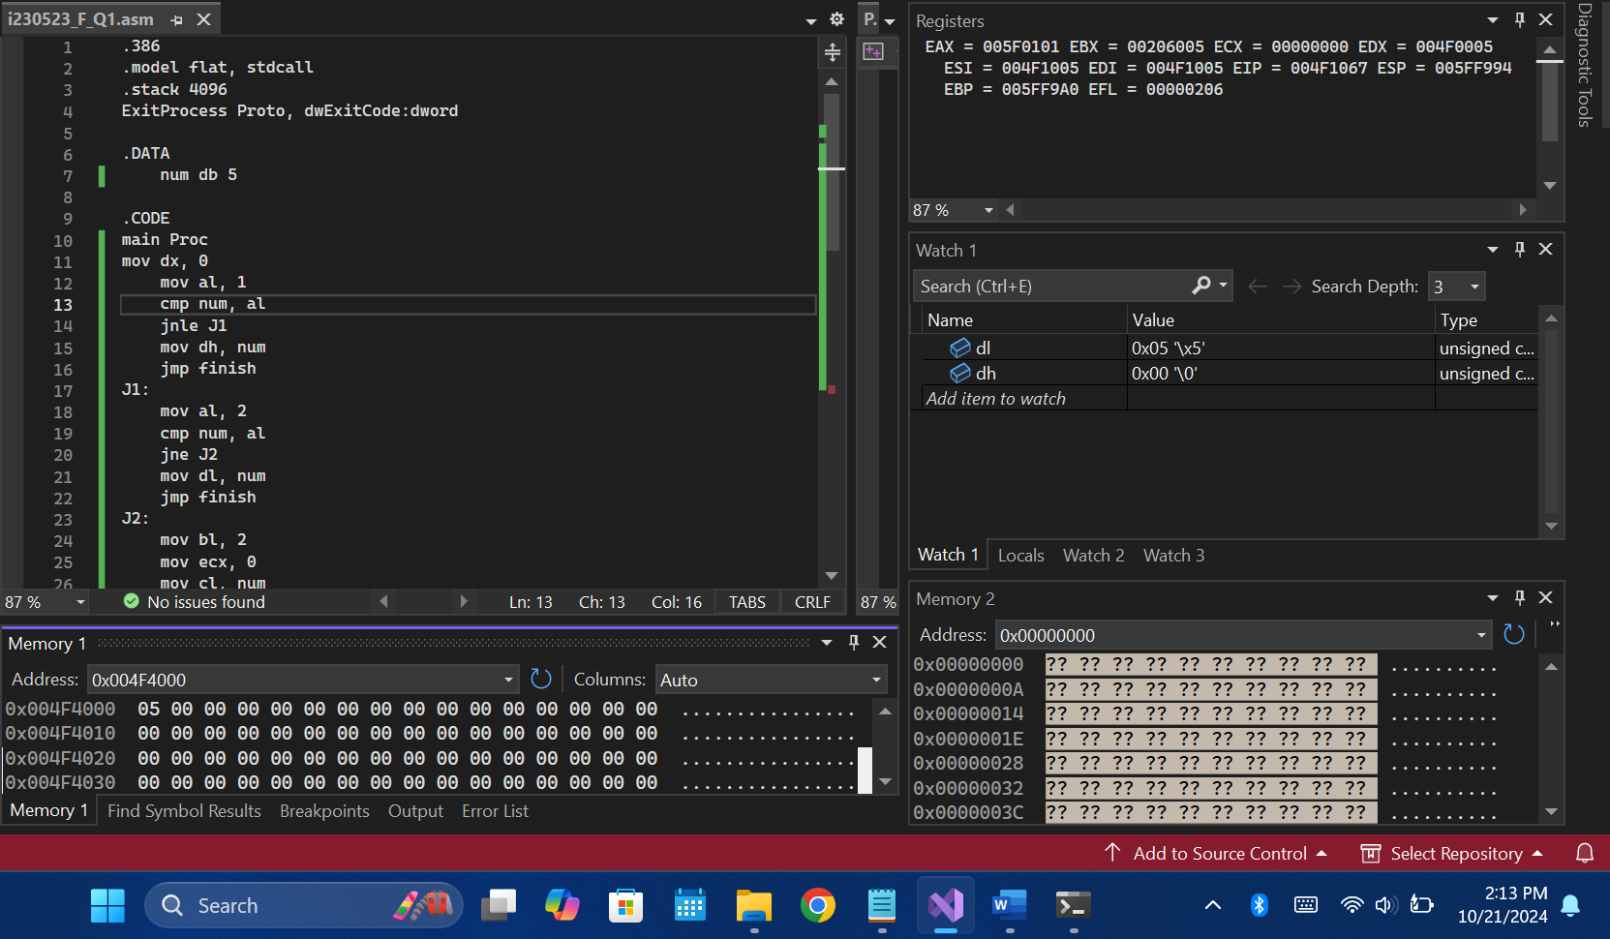
Code:
.386
.model flat, stdcall
.stack 4096
ExitProcess Proto, dwExitCode:dword

.DATA
num db 5

.CODE
main Proc
mov dx, 0
mov al, 1
cmp num, al
jnle J1
mov dh, num
jmp finish
J1:
mov al, 2
cmp num, al
jne J2
mov dl, num
jmp finish
J2:
mov bl, 2
mov ecx, 0
mov cl, num
sub cl, bl

L1:
mov ah, 0
mov al, num
div bl
cmp ah, 0
jne J3
mov dh, num
jmp finish
J3:
mov dl, num

inc bl

Loop L1

finish:

Invoke EXitProcess, 0
main Endp
End main
- Initialize a random array of 10 elements. You are to find the second largest and second smallest element in that array. Store them in separate variables.
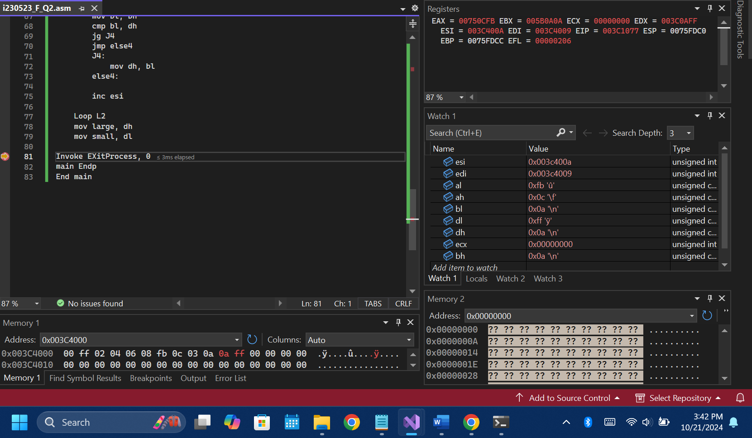

Code:
.386
.model flat, stdcall
.stack 4096
ExitProcess Proto, dwExitCode:dword

.DATA
arr db 0, -1, 2, 4, 6, 8, -5, 12, 3, 10
large db 0
small db 0

.CODE
main Proc
mov esi, offset arr
mov al, [esi]
mov dl, [esi]
mov bx, lengthof arr - 1
mov edi, esi
add di, bx
mov ah, [edi]
mov dh, [edi]

;Largest and smallest
mov ecx, lengthof arr
L1:
mov bl, [esi]

;;;For smaller num:
cmp bl, al
jl J1
jmp else1
J1:
mov al, bl
else1:

;;;For larger num:
cmp bl, ah
jg J2
jmp else2
J2:
mov ah, bl
else2:

inc esi
Loop L1

mov esi, offset arr

;Sec Largest and sec smallest
mov ecx, lengthof arr
L2:
mov bh, [esi]

;;;For smaller num:
cmp bh, al
je else3
mov bl, bh
cmp bl, dl
jl J3
jmp else3
J3:
mov dl, bl
else3:

;;;For larger num:
cmp bh, ah
je else4
mov bl, bh
cmp bl, dh
jg J4
jmp else4
J4:
mov dh, bl
else4:

inc esi

Loop L2
mov large, dh
mov small, dl

Invoke EXitProcess, 0
main Endp
End main

- Write Assembly program to Input Character from user and display it.
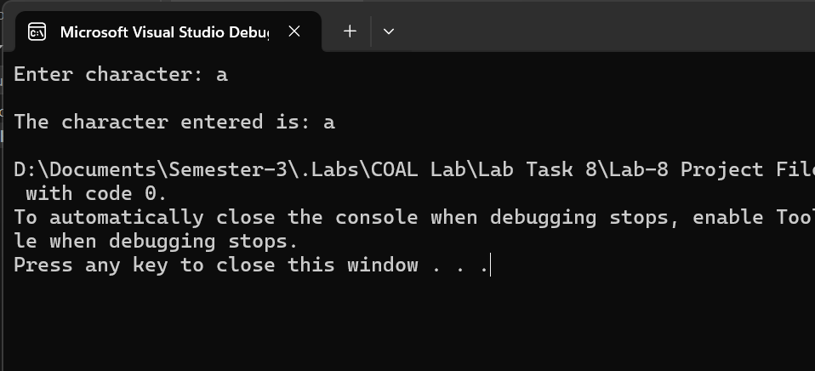
Code:
.386
.model flat, stdcall
.stack 4096
ExitProcess Proto, dwExitCode:dword

GetStdHandle PROTO, nStdHandle: DWORD
WriteConsoleA PROTO, a1:DWORD, a2: PTR BYTE, a3: Dword, a4: ptr dword, a5: dword
ReadConsoleA PROTO, a1:DWORD, a2: PTR BYTE, a3: Dword, a4: ptr dword, a5: dword

.data
str1 db "Enter character: ", 0
str2 db 0Ah, "The character entered is: ", 0
num db ?
x dd ?

.code
main proc
invoke getstdhandle, -11
invoke WriteConsoleA, eax, offset str1, lengthof str1, offset x, 0
invoke getstdhandle, -10
invoke ReadConsoleA, eax, offset num, lengthof num, offset x, 0
invoke getstdhandle, -11
invoke WriteConsoleA, eax, offset str2, lengthof str2, offset x, 0
invoke getstdhandle, -11
invoke WriteConsoleA, eax, offset num, lengthof num, offset x, 0

Invoke EXitProcess, 0
main Endp
End main
- Write Assembly program to Input upper case letter from user and display lowercase.
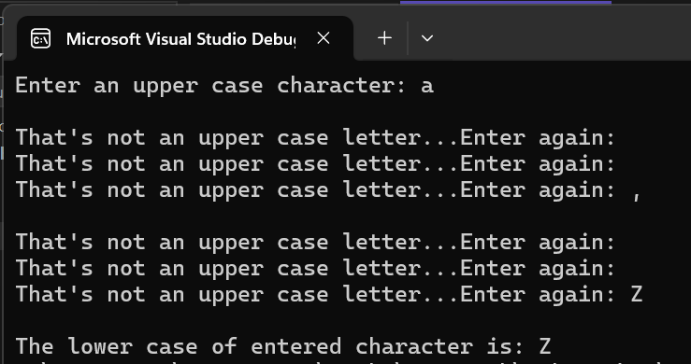
Code:
.386
.model flat, stdcall
.stack 4096
ExitProcess Proto, dwExitCode:dword

GetStdHandle PROTO, nStdHandle:dword
WriteConsoleA PROTO, a1: Dword, a2: ptr Byte, a3: Dword, a4: ptr Dword, a5: Dword
ReadConsoleA PROTO, a1: Dword, a2: ptr Byte, a3: Dword, a4: ptr Dword, a5: Dword

.DATA
str1 db "Enter an upper case character: ", 0
str2 db 0Ah, "The lower case of entered character is: ", 0
str3 db 0Ah, "That's not an upper case letter...Enter again: ", 0
char db ?
x dd ?

.CODE
main PROC
mov bl, "A"
mov bh, "Z"

Invoke getstdhandle, -11
Invoke WriteConsoleA, eax, offset str1, lengthof str1, offset x, 0
jmp No

Again:
Invoke getstdhandle, -11
Invoke WriteConsoleA, eax, offset str3, lengthof str3, offset x, 0

No:
Invoke getstdhandle, -10
Invoke ReadConsoleA, eax, offset char, lengthof char, offset x, 0

;----- Input Validation -----
cmp char, bl
jl Again
cmp char, bh
jg Again

Invoke getstdhandle, -11
Invoke WriteConsoleA, eax, offset str2, lengthof str2, offset x, 0
Invoke getstdhandle, -11
Invoke WriteConsoleA, eax, offset char, lengthof char, offset x, 0

Invoke ExitProcess, 0
main Endp
End main
- Create an Array of 10 elements of size BYTE. Ask user to input index of an element and print that element and get the next element i-e (index + 1)
- Write an assembly program that takes an input and tells whether the given number is even or odd
- Write Assembly program to input letter from the user and display the previous character.
- Take the marks from user and display the letter grade. (Use the following table)

a < 5 | D
5 ≤ a <7 | C
7 ≤ a < 9 | B
=9 | A

- Write a program that displays the following output.

*****
*****
*****
*****
*****

b) *
**
***
****
*****
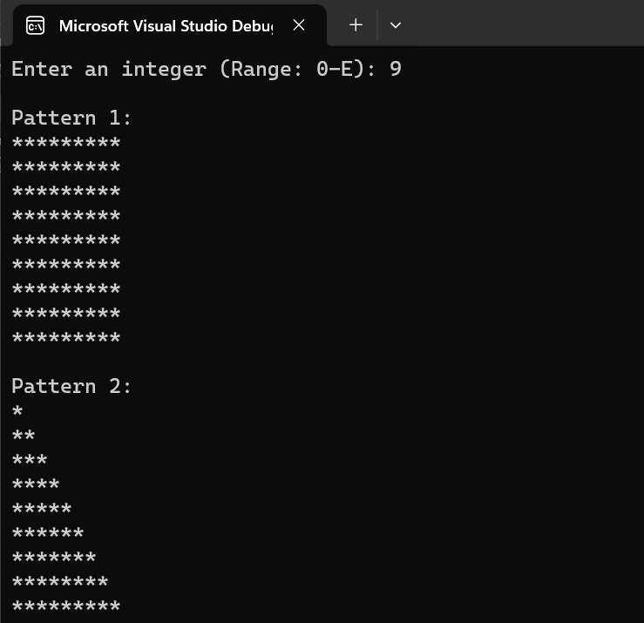
Code:
.386
.model flat, stdcall
.stack 4096
ExitProcess Proto, dwExitCode:dword

GetStdHandle PROTO, nStdHandle:dword
WriteConsoleA PROTO, a1: Dword, a2: ptr Byte, a3: Dword, a4: ptr Dword, a5: Dword
ReadConsoleA PROTO, a1: Dword, a2: ptr Byte, a3: Dword, a4: ptr Dword, a5: Dword

.DATA
str1 db "Enter an integer (Range: 0-E): ", 0
str21 db 0Ah, "Pattern 1: ", 0Ah, 0
str22 db 0Ah, "Pattern 2: ", 0Ah, 0
str3 db 0Ah, "Invalid input (Range: 0-E)...Enter again: ", 0
num db ?
stars1 db 500 dup(?)
stars2 db 500 dup(?)
x dd ?

.CODE
main PROC
mov bl, 0
mov bh, 45h

Invoke getstdhandle, -11
Invoke WriteConsoleA, eax, offset str1, lengthof str1, offset x, 0
jmp No

Again:
Invoke getstdhandle, -11
Invoke WriteConsoleA, eax, offset str3, lengthof str3, offset x, 0

No:
Invoke getstdhandle, -10
Invoke ReadConsoleA, eax, offset num, lengthof num, offset x, 0

;----- Input Validation -----
cmp num, bl
jl Again
cmp num, bh
jg Again

mov bl, num
mov bl, 48
cmp num, bl
jl skip
sub num, bl
skip:

;--------- (a) ---------;

mov dl, "*"
mov dh, 0Ah
mov esi, offset stars1
mov ecx, 0
mov cl, num
L1:
mov ebx, ecx
mov ecx, 0
mov cl, num
L2:
mov [esi], dl
inc esi
Loop L2
mov [esi], dh
inc esi
mov ecx, ebx
Loop L1

;--------- (b) ---------;

mov dl, "*"
mov dh, 0Ah
mov esi, offset stars2
mov ecx, 0
mov cl, num
mov ah, 1

L3:
mov ebx, ecx
mov ecx, 0
mov cl, ah
L4:
mov [esi], dl
inc esi
Loop L4
mov [esi], dh
inc esi
inc ah
mov ecx, ebx
Loop L3

Invoke getstdhandle, -11
Invoke WriteConsoleA, eax, offset str21, lengthof str21, offset x, 0
Invoke getstdhandle, -11
Invoke WriteConsoleA, eax, offset stars1, lengthof stars1, offset x, 0

Invoke getstdhandle, -11
Invoke WriteConsoleA, eax, offset str22, lengthof str22, offset x, 0
Invoke getstdhandle, -11
Invoke WriteConsoleA, eax, offset stars2, lengthof stars2, offset x, 0

Invoke ExitProcess, 0
main Endp
End main

